INSTITUTE OF CULTURAL AFFAIRS KENYA
- BACKGROUND
The institute of Cultural Affairs is a not-for-profit, non-sectarian, independent organization working in 35 countries. It is primarily concerned with the human factor in world development and is staffed by volunteer workers from many nations, and all races and cultures.

- KENYA HISTORY
The ICA began working in Kenya in 1968 conducting training courses. In 1973, upon local requests, the ICA established a residential training center in Nairobi. The institute rapidly expanded its work to rural villages across Kenya. Expansion continued as new villages particularly in doing their own development. The ICA was registered under the Societies Act of Kenya in 1978. Kawangware (Nov 9–15, 1975)
Nairobi, Kenya

- HUMAN DEVELOPMENT PROEJCTS
In November 9th to 15th 1975, a Human Development Project was established in Kawangware. It included a Demonstration Urban Farm, construction, sewing and handcraft industries: a business-man’s association; and training for pre-school children, youths and adults. The project, according to city officials, was a major factor in reducing the crime rate in the area. This project continues in an intensified manner in a small geographical area known as the Kabiro Human Development Project. In 1978, the ICA decided to also work in the rural and the Kamweleni HDP was registered under the Societies Act of Kenya in 1978.

- VILLAGE INITIATION USING ICA ToP METHODS IN KENYA
The village chosen to become Human development Project each sent ten members to the Human development Training Institute. A five day initiating consult like the consult described in launching the Kamweleni Human Development Project was held in each village. Each consult had a large representative group from all parts of the village and all areas of leadership. The product of each consultation was a two-year development plan created by each village. During the consult each village is divided into five geographical areas called stakes. All planning for the implementation of the two-year timeline began in the stakes. In this way the broadest representation possible was achieved in each village. Recommendations from the stakes went to the community where plans are drawn together and consented on by the whole village. The plans were then sent to village task forces or guilds that prepare and carry out the implementation procedures. Many of the tactical events were also assigned to stake and community-wide workdays for implementation.

- KEYSTONES OF SUCCESS
The following list of four Basics and ten Methods were used for building the Kenya Replication Scheme.
  - Basics
    - Village Catalysis: The basic task was to catalyze the villages to carry out local development by themselves as they begin their own village and move to various levels of clusters of villages. This presupposed that local people have what is necessary to begin building their own future. The basic task was to awaken them to this possibility through a planning process that brings about a change in attitudes and objectives. ToP Methods for conducting grassroots development process which were taught, and organizational structures and dynamics conveyed that enabled participation by the village in the development of the whole village. The structures and dynamics were created that enabled participation and integrated and enhanced the decision-making processes which were extended to all levels of village clusters.

    - Local Staffs: Not only was the village catalysis key, but the local sector itself was able, with proper training, to do the job of catalyzing the local to do self-generating development. The staff and the majority of movemental forces were local people and live and work in village shoulder to shoulder with the villagers.

    - New Village Movement: A vision of village movement grounded in a constant expansion/intensification scheme was a necessary part of awakening and sustaining human development in the villages. This was symbolized by each village project joining or becoming a part of the “New Village Movement”. When a village realized itself as a part of a broad and growing scheme of mass catalysis this feeds its spirit decision to do its own development. The “on behalf of the 2,000,000 villages across the globe” image may then become practically evident.

    - Village leaders Movement System: As the replication process grew, more and more leaders were trained to do their own development and the possibility of local development beyond their own village. More and more they assumed responsibility for the wider development process. Thus, the role of village leaders in enabling the whole forerunners of the leadership of the whole grass roots development process and mass rural mobilization.

  - Techniques
    - National Phased Replication Scheme
    - Project and cluster expansion tools and techniques
    - The “ Do-our-own-project” (DOOP) Model
    - Cluster structure and operating tools and techniques
    - Training forms and structures for staff and villagers
    - Project –wide regular staff conciliar planning meetings and activities
    - Common operating procedures and structures throughout the project both in missional task and staff style
    - Decentralized programmatic and monitoring activities
    - Living in the villages and operating out of them to other villages
    - Calling for the national staff from the villages to serve the new village movement

- RURAL EMPHASIS
The ICA worked in four areas of ToP methods: training, consultations, village planning methods and human development projects. The methods helped the facilitators to emphasis on the development of rural villages where 80% of the world population lies. The methods empowered and provided techniques to the local communities to engage in their own sell-development from the grass roots level up. The methods also enabled the facilitators to the communities to services providers to solicit for support and participation from public, private, and volunteer sectors.

- HUMAN DEVELOPMENT TRAINING INSTITUTE
The Kenyan replication scheme call for a large number of staff to be quickly trained to pick up the roles of project directions, staff and village leadership. The human development training institute was responsible and operated with the following objectives. First, the participants learn how to identify the actual human needs in different types of communities. Second, they learn about and see with their own eyes practical, new ways of dealing with age-old problems that have seemed insolvable, and to utilize the local resources, government services and appropriate technology available for resolving them. Third, they are trained in ToP methods of corporate leadership which allow them to work as a team and to create the motivation necessary to engage an entire community in the common planning and actuating of its development. Hence, the training institute was not concerned to produce experts in a particular field, but a capable and motivated leadership core which can serve any local community in its overall development efforts. The of staff who graduated from HDTI between 1982 – 83 were 210.

- BASIC CURRUCULUM
To accomplish these objectives, the training institute used a threefold organizational model consisting of cycles, excursions and colloquies during the seven weeks: three major academic cycles, two excursions and an opening and closing colloquy. The basic curriculum was constituted by the three cycles of study, covering all facets of village development: the economic, the cultural and social. These cycles were further sub-divided into nine programmatic arenas, each of which was dealt with in an intensive two-day module designed to quip participants with both an overall grasp of the arena and practical methods for catalyzing its rapid development in a village. The second structural component of the curriculum consisted of two major excursions, each three days in length. The first of these was an encounter with the profound heritage of Kenya’s rich history and the great social intervention which have contributed to human civilization. The second was encounter with the global and urbanized world, usually a trip to Nairobi as the guest to government departments and business houses which confronts participants with an understanding of the vast technological and human resources which this new world makes available to the local development efforts. Finally, the training institute began with a three-day council which orients new participants to its total curriculum and style; and concluded with a three-day council in which those who were about to graduate were joined by representatives of the existing projects, share reports on the progress of the nation-wide effort and coordinate plans and schedules for the coming three months.

- BASIC COMMITMET
The Human Development Training Institute was for men and women of every background who care deeply about the future or rural communities. It required of all applications accepted for admission a decision to engage themselves full in the two months of training in order to become familiar with ToP methods and operations. It also asks that every applicant consider seriously a two year project assignment following the training programme. Those selected for the progamme were to be willing personally to share the living conditions of the village for the sake of giving of genuine service to the local people. They must be capable of adopting a disciplined and corporate style of life appropriate to the local situation. They must be willing to engage in hard intellectual and physical work during the eight weeks of training. This practical training offers significant engagement for those who have decided to care for the villages across the nation of Kenya.

- EVIDENCE GATHERING ON ICA IMPACT IN KENYA
Following a number of conversations with various ex-employees of ICA Kenya, the ICA:UK Board have now approved a research project which seeks to understand better the impact that ICA’s work has had in Kenya over the past 40 years. We see the output of the research being useful evidence for any individual and/or organization concerned with facilitation and community development; and to support proposals/funding applications of Kenya-based organizations using the ICA approach by providing evidence that the approach is viable and effective in the Kenyan context
The intention is that this should not be a highly rigorous, sophisticated attempt to evaluate all ICA projects across Kenya, but rather a more modest, storytelling-based approach based on a few selected areas but which will nevertheless produce some interesting and valuable findings. The research will focus on five main areas in Kenya, all of which have hosted ICA programmes in the past (current thinking is for Nairobi, Isinya, Il Ngwesi, Machakos and Mariakani). The format would be conversational, eliciting stories about peoples’ experiences of what they do, how they connect with and use ICA approaches and more importantly, the difference their actions made – to themselves, the communities or in the wider society.

During this evidence gathering research, the team visited some of the former ICA staff in Kawangware, Machakos, Kilifi/Kwale and Isinya and recorded the following
JUDY WANGARI  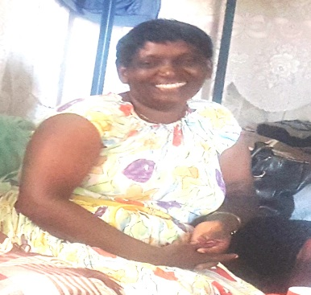  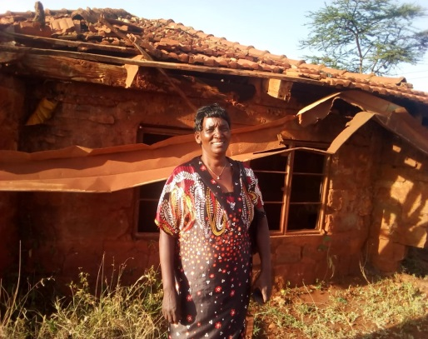 |  | Judy Wangari was recruited from Kabiro and attended the 1st Human Development Training Institute in Kawangware. After the training Judy was assigned to Kyuluni Kivulusa Human Development Project in Machakos, back to Kamweleni, then to Maikuu-Muthungwe which were also in Machakos. Later, she was moved to Vevwesi Human Development Project in Kilifi, Mombasa coast region.  A part from field assignments, Judy also became a trainer of the subsequent HDTIs where she was promoted to become the dean. She was on assignment commission; a facilitator in village consults which was carried out when a new project were launched. She was a trainer in LENS and strategic planning processes. She became a trainer of trainers (TOT) in the use of conversation methods.  Judy has continued using ToP methods such as Conversation, workshop methods and training in facilitation skills. She has facilitated groups in Strategic planning and also in research studies. She once was in charge of a kindergarten school under the Gender relations and child protection programme. She has facilitated and organizes workshops, train others in different skills. Celebrating families with parents of the school and church.  Judy has the potential and experience to take the ToP methods to higher level. She is confident and willing to give back to society the skills and sharing those methods she acquired. She is able to translate a new concept and find relevance in what she learnt in ICA.  The ToP methods were relevant then and still very relevant now. What is needed now is a refresher training in order to organize, introduce and advance these to people like Sammy who are critical in community development? “Teach us about real public participation”.  This exercise has been very important. It has helped me reflect on what I am currently doing and has reconnected me with old friends and people I met while in ICA. Judy was grateful to meet former ICA colleagues for reminding her where she came from and where she is today – still using ICA methodologies.
NATHAN AMBUNYA  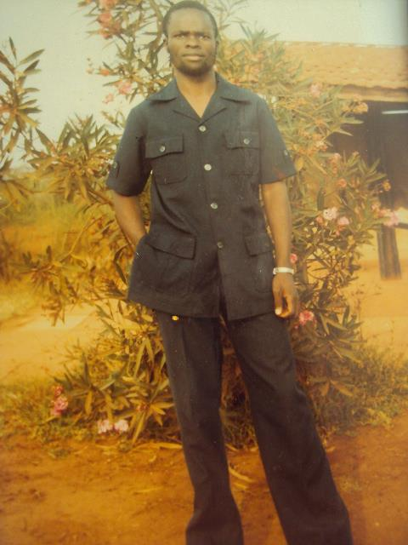  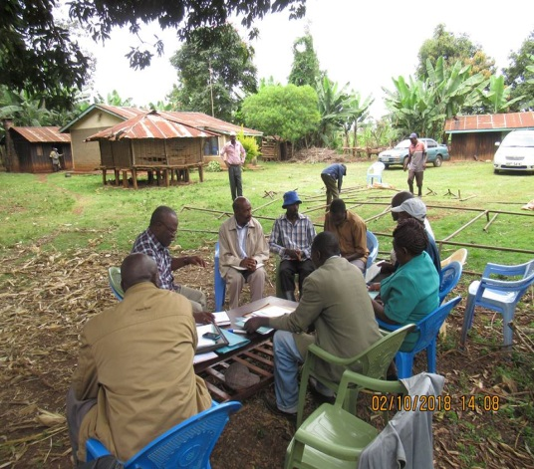 |  | Nathan Ambunya attended the 6th Human Development Training Institute at Kameweleni HDTI Centre. He then was assigned to Nguluku Human Development Project at the coast as a project circuiter. He was then moved to Ng’araria Human Development Project as the project director, later to Chororget and Vwevwesi Human Development Projects in the same capacity and to Mugumoini Human Development Project as a section gun. Nathan was again moved to head office Nairobi to be part of the fundraising team and the CMPP team to train the cooperative society staff in Leadership Effectiveness and New Strategies (LENS). The ICA in its effort to locally generate income they secured work with the Ministry of Agriculture and Irrigation and companies around Nairobi, Thika and Arthi River. Nathan was assigned to Ahero as the project director to head activities in Irrigation for the Ministry of Agriculture and Irrigation.  In all these activities and assignments Nathan learned, practiced and facilitated Community mobilization, lens training, Village meetings, Consults meeting, training cooperatives staff, Stake meetings etc.  To date, Nathan can easily remember Workshop methods, Conservational methods, Emerging education, Training, Facilitation and AAMMEE. He still uses Workshop methods, Conservation methods, training skills and facilitation. This has made him be accommodated in various groups and institutions. Thus, he is always chosen as a leader in every development activities.  The ToP methods have enabled communities to meet their vision and implement them. Currently Nathan is working with19 irrigation farmer groups which have been established and are operational on 50/50 contribution. The challenges have been when dealing with people who are not conversant with the method and also when you deal with people who are not ready to humble and learn.  The Community Development work has given hope to communities, directions and can implement their own activities even without our presence after projects have been initiated. Where former ICA worked the Communities are more empowered if you compare. During the ICA and even after, some former staff has continued to work with communities such as irrigation projects by providing consultant services.  The value and the benefits of ICA methods, makes you human in your day to day interaction with individuals and groups. They are very relevant in enabling groups to conclusively discuss issues and when you are dealing with workshops, conferences, group meetings and family meetings and individual discussion. ToP methods is a way of life and can still be used in our villages, counties, wards, staff meeting, when we want to interchange experiences with other people especially in strategic planning. When engaged in such approaches I can be involved in facilitation by creating regular forums that need facilitation or trainings and planning both external and local. This means therefore it is going to be important of us to continue practicing the methods with dedication and commitment.
GRACE MUIA  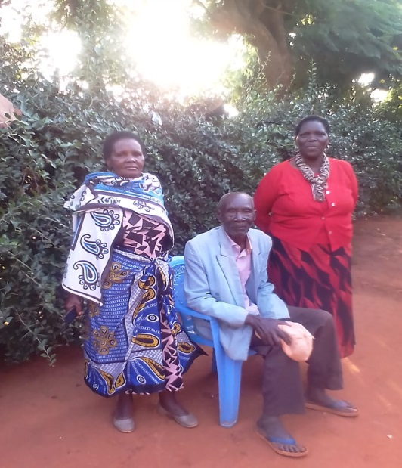 |  | Grace Muia attended the 10th Human Development Training Institute in Kameweleni HDTI Centre. She was then assigned to Gatitu Human Development Project, then to Vevwesi and back to Kamweleni HDP. From Kamweleni she was assigned to head office Nairobi and later assigned to a special programme credit management and business training in Murang’a. Grace moved from being a village circuiter to becoming a section gun then TOT for village leaders’ institutes. The HDTI training in Kamweleni introduced Grace to ToP methods where she continued practicing during the field work while she was in ICA and when she left ICA due to narrowed funding of programmes. The methods included focused group discussion, workshop methods, strategic planning, Leadership Effectiveness and New Strategies (LENS) etc.  Grace has continued using ToP methods in facilitating community based meetings in her county, (Nairobi). More recently used in Community discussions, meetings and to action planning, e.g. a peace keeping event for the Dagoretti Community Network.  Presently Grace is self-employed, making liquid soap which she sell locally; curry-out community mobilization and carry out training on life skills in business management and table banking. She is also a member and secretary of CAPI. Grace is a self-motivated in planning for her family, organized to raise income and bring-up her family as a single parent without regular income. This has busted our livelihoods. She has also used her experience in soap making to train and empower the community in the same. Grace has continued to participate in community organizations such as Network meetings which happen every Thursday.  By being active, Grace broadened her community development skills in communication and relationship building which has widened her networks. She agrees that the ToP methods are still very relevant. This exercise is a reminder of what she learned and has continued the application of the methods in many areas as they are replicable in different contexts. She is grateful to go through the exercise as it reminded her of how useful the ToP methods which is still fresh in her mind.
PATRICK MBULLU  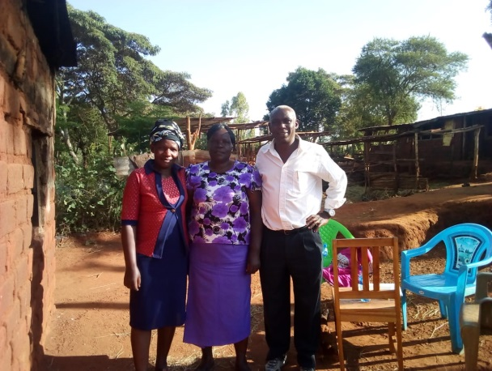 |  | Patrick Mbullu attended the 2nd HDTI in Kamweleni . After the training Patrick was assigned to Kabiro Kawangware, Kipsianani Koisamo, Kaongo, Mugumoini and Vwevwesi Human Development Projects respectively.  A part from being assigned as a circuitor and elevated to a project director and a section gun, Patrick also trained HDTI no. 3&4. He was a member of the Panchayat team, a researcher while in Canada, Cooperative Members Participation Programme (CMPP) trainer, trainer in ToP methods (UK) and coordinator of village volunteers’ project in Uk.  Patrick can still remember LENS training he facilitated for Tiger Shoe Company. Group Facilitation Methods I & II = Conversation (Kenya & Canada), Workshop and Strategic Plan (Kenya and Brussels). He has been a Training of Trainers (TOT) and a Volunteer training in the UK.  Patrick has tailored and used the different levels at different contexts – examples: SCIAF – organized series of workshops with partners across Africa on HIV/AIDS; during monitoring visits and designing evaluations to assess impact of funded projects Khanya – incorporated into Community Driven Development – designed training materials for Masters Programme for the Free State University; work on the 4-country action research – Kenya, Lesotho, Peru, South Africa and Uganda; a training and facilitation event with the Western Cape agriculture department and other assignments. Voluntary Action Fund – introduced and integrated into the way we monitored and evaluated impact of funded projects and pulling together outcomes of over 60 projects. University of East Anglia (UK) – based my dissertation on the use of the methods – using Siaya project and Faculty of the Volunteer training programme with ICA:UK  Patrick says ICA ToP Methods improved his competency when liaising with different levels of governance and communities. Coaching and mentoring others in the use of the tools. Scottish Government adopted the approach in funding projects – e.g. using outcome-based to make decisions. Funded projects – ability to translate activities into outcomes and to produce quality reports; the more people participate in identifying their indicators the better in monitoring them. SA government strengthened in facilitating authentic plans and implementation nationally. Introducing and selling the approaches to new clients. Slow/shy to market the methods. How to ensure continuation beyond the training and facilitations events. If used well the methods are useful in ensuring ownership and sustainability of outcomes  Despite promotion of community participation in decentralized systems, majority of it is about extracting information from local people. There is need for authentic participation that lead to clear implementation of plans  Communities and governance structures need to practice authentic participation to arrive at informed decision making. If effectively used and followed through, the methods are cost effective compared to other forms of community mobilization. The methods are still very relevant as today’s public participation is not real participation which is tailored participation intended to telling people what they need to hear. Kenya is currently promoting community involvement in its decentralized structures. in this case former ICA staff could repackage ICA ToP methods for training County officials to truly practice real participation. Participation that is empowering, responsive to the local needs. Reactivation of the methods in Makueni County and organizing Group Facilitation training events with local NGOs and with former ICA Kenya. The Short term reviews and impact assessments with ICA:UK & Canada is aiming at establishing the need of having a more in depth impact assessment in future.  However, it was an opportunity and really nice to link up with former colleagues and seeing their interest in the methods. It has been revealing to meet others who have been exposed to the methods, how they currently use and continue to be influenced by the tools in their daily work.
HENRY IKATUKHU  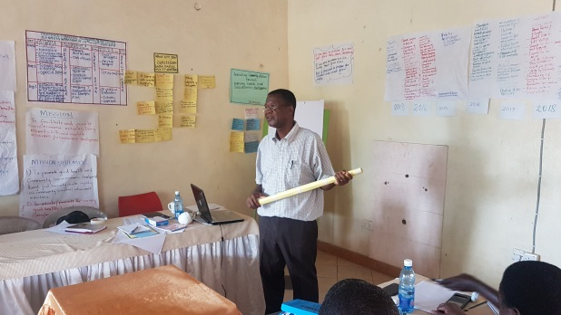  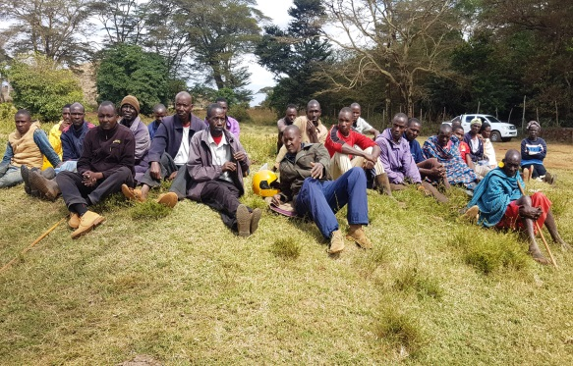  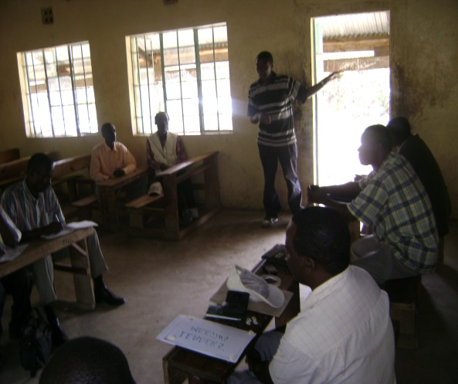 |  | Henry Ikatukhu was recruited from Kawangware attended the 2nd HDTI training in Kamweleni which was the first in the rural areas. After the training Henry was assigned to Kyuluni Kivulusa Human Development Project in Machakos. He was moved after one year to Chororget Human Development Project in then Elgeyo-Markwet, Rift-Valley, then to Ngutu Human Development Project in Murang’a District. From Ngutu, Henry was assigned to Kalwani Shamalago for year then moved to Nairobi where joined the production and documentation team then to fundraising team. While on fundraising team he was assigned to Brussels to meet donors in Belgium, German, Netherlands and the United Kingdom. In 1984, he was one of the 34 Kenyans who attended the ICA global conference held in Chicago USA. At this conference he was assigned to Cote D’Ivoire together with his family. In 1987, he came back to Kenya and assigned to grant monitoring team.  Henry held several position while ICA including as a circuiter in Kyuluni-Kivulusa, a project director in Chororget and Ngutu, a fund raiser in Nairobi, Belgium and UK, a proposal writer in Nairobi, a section gun in Kalwani-Shamalago covering western Kenya, Nyanza and part of Rift Valley regions, a field coordinator in Cote D’Ivoire and also while still in Cote D’Ivoire went to Belgium and Netherlands for fundraising.  Henry learned most of the ICA ToP methods through on the job training. These included Workshop methods, Conversation methods, Art form methods, Strategic planning process and Image shift which he still uses to date.  As Larry Philbrook would put it, ICA is inside you and because of that Henry has gained more Self-confidence which has given his opportunity to provide services. It has made him a practitioner in community development in East Africa Region. He has become an expert in formation of the Irrigation and Water Users Associations.  Where ICA worked the community contributes to ideas of development more effectively and participates positively in the implementation activities. Most of community people trained by ICA methods are resourceful to the wider society. The community trained by ICA depend less on external support. The communities who have been involved in ICA methods in participation processes.  Some of the challenges Henry has encountered while using ToP methods is accepting to be different. Lack of approval of competency and a question always asked “which university did you learn ToP methods”?  The ToP methods do not seem to be Accredited to any known institution.  People in the community are at different level of knowledge and education. Some have a lot of experiences in life. To establish some levels of positive and understanding, there must be some processes of eliciting information to create common understanding. ICA methods feed well in these situations. Common development work is a process that must be followed to the latter  The ICA ToP methods streamline your thinking progressively. The methods can increase your success levels and can help you to plan for short term and long term congruently.  The need for grassroots planning is more relevant than before and ICA methods could be the only answer. The governing system in has been devolved to county governments where the process needs to go upto the community level. The ICA methods initiated projects from the village level even though the divided into stakes then expanded to the sub-location and to the location having planning sessions at every level. This is needed now than before because administrators of development have been put in place with no idea of what to do.  This region needs ToP methods more than before. We can start where we stopped especially in Counties. Communities needs ToP methods to plan effectively for their development programs. ICA left some communities without a proper plan of capacity building and handing over. I will want to be part of a network that will re-document ICA ToP methods in Kenya into useful packages/tools. Seek support from friendly ICAs from other regions on peer to peer bases. Research on how the ToP methods can be accreted in a professional institution in Kenya. I’m willing to join with others in networking and marketing ToP methods.
MERCELINE ATINGA  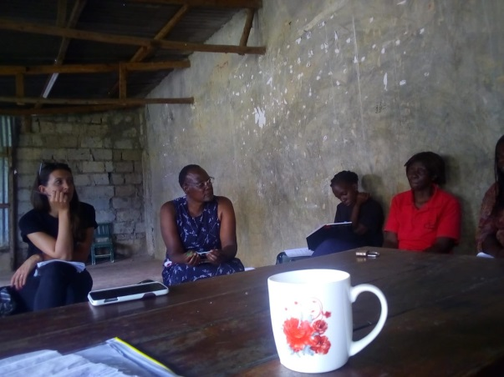 |  | Merceline Atinga joined ICA in 1983 and abstained in 2006 due to low funding of agricultural activities. She was recruited from Saboati Human development Project in trans nzoia and attended the 10th Human Development Training Institute at Kamweleni Training Centre. After the training Mercyline was assigned to Muni-mwanyani Human Development Project in Machakos. She was then transferred to Chororget Human Development Project in the then Elgeyo Markwet District Rift-Valley Province. She was again transferred to Mukumoini Human Development Project in Murang’a District. During all these assignments, Mercyline facilitated meetings, training and strategic planning in the communities. She also participated in documentation of projects reports and staff development. She was part of the team that was assigned to compile publish ICA Kenya newsletter. Mercyline was assigned to Murang’a where she participated in women group formation and registration.  The workshop and conversation methods have been the main tools Mercyline has used in work. The AAMMEE methods developed by the Nairobi Health Training Programme of which she was part of the team made the programme a success. After ICA Mercyline has continued to be involved in community development activities which has enabled her to learn new skills such as mentorship, life skills and counseling. In local community she participates in workday planning and environmental activities.  Mercyline agrees that ICA methods are adaptive, unique in its own way and very different from other trainings that she has attended organized by other institutions. The challenges she have faced while using ICA ToP methods has been inadequate resources to support the programmes, for example finances. Working individually it becomes difficult to be supported in terms of materials and follow ups to assess how effective is the methods. She has no idea how other regions have moved on with ToP methods since ICA Kenya went under. This is to say, I have not been keen to assess my own community development work.  However, I have benefited from the methods in that I still apply them and am able to earn from them. The methods have encourages me to be who I am. I’m confident in terms of what I do whereby the methods have always helped me to think through what I want to do and solve issues.  The ToP methods are still very relevant and never grow old and currently the methods can be used in the county government setup to make administration levels more effective starting from community unit, village and ward levels. Mercyline would like to be able to do more practices on the ICA ToP methods, apply them more and more and attend to refreshers courses if available.  Being asked these questions I feel refreshed and I feel ICA is live in me.
NZILANI MUTUA |  | Nzilani Mutua attended the 4th HDTI in Kamweleni in1980. After the training she was assigned to Kitandi Human Development Project in then Machakos District in the same year before it was divided and became Makueni County. In 1981 she was transferred to Vevwesi in Kilifi, Coastal Region where she worked for one year and moved to Mukumoini in 1982 where she also worked until 1983. In 1984, she was assigned to Kilisa Kyamue she worked for one year before moving to Kamweleni in 1985 to 86, then to Kamwala in 1987 to 1989, then back to Kamweleni in 1990 to 1991. In 1992 Nzilani was transferred to a new named Mutonguni in then Kitui District. In 1996, she was seconded to Community Organisation Consultant by ICA Kenya for a period of two year to undertake an assignment in Mwatate, Taita-Taveta in the coast region. In 2002, she was assigned to Isinya where worked for 3 years.  Through these assignment Nzilani has gone through on job training which includes Consults, Facilitation, Trainer/ training of trainers, VLTS, Advanced Leaders Training, CMPP – consultant with cooperatives, Fundraising with Jean Smith, Proposal Writing, Nakuru agriculture training with the Ministry of Agriculture (1990/91),  Nzilani can easily remember and facilitate ToP methods TOP – I,2,3, LENS, CMPP, strategic planning and Nairobi CPD.  Currently she uses ToP methods advising and facilitating group members in Community table banking and as a treasurer in Kyeni kya Nduu Ndune a self-help group. Member of a number of community groups, funeral welfare, merry-go-round, loan schemes (Muranga, Kisii, Western- Kakamega, Mumias and Bugoma).  Also, in managing self and family finances, Planning on how I spend my time, e.g events that are ongoing in the community, public participation for the local ward. This makes me feel satisfaction of being of service to my community. Able to intervene in meetings to arrive into consensus in group discussion (mwethya) normally asked to help facilitate hard discussions. Evaluating my children/family performance and normal family discussions, wider/extended family get together. Asked to lead Organizing traditional home functions (1st born). Asked to play a critical role to bring together all 9 siblings + their descendants. Translating the “concept” of challenges from negative to positive – especially in local contexts. Many people usefully don’t perceive challenges as areas to learn from but blockages. Financial constraints to advance the tools in my community /country/family.  In all my experience I have come to realize the community development is about enlightening communities through processes and training, participating in regular meetings and advising others, extends own exposure in approaches, knowledge about communications with wider variety of audiences. Given that I was fresh from tertiary education when I joined ICA, I have grown with ToP methods and I’m confident in addressing group gatherings at all levels.  The ToP methods can’t be replaced with normal knowledge and tools that are said to be ‘public participation’. Authentic participation is about allowing people to express their ideas openly, extend and share knowledge/experience widely especially with the devolved government in Kenya and in with my family and neighbors, council and advise.  When and if there is chance to be involved e.g. this exercise to facilitate and planning workshops  Link with the local authorities via contacts like Charity Gathuthi I will like to be involved.
ELINA IKATUKHU  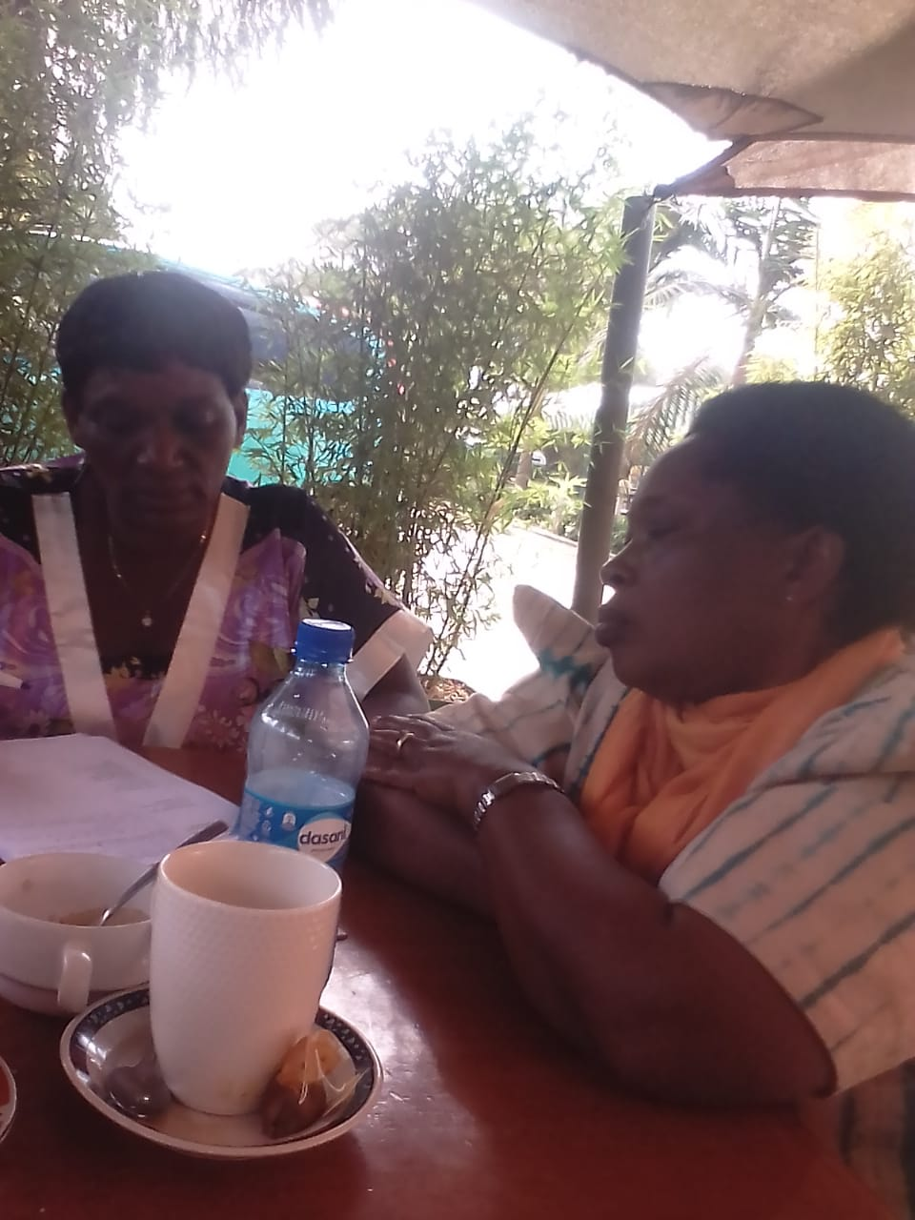 |  | Elina Ikatukhu attended the 8th HDTI at Kamweleni training Centre. After training , Elina was assigned to Chororget Human Development Project then to Ngutu Human Development Project and later to Kalwani-Shamalako which was then the Section A covering the Western Region of Kenya.  Between 1984 to 1987, Elina was assigned to Brobo Human Development Project in Cote I’d Voire whereby after the four year assignment she came back to Nairobi and was assigned to finance office in the ICA Kenya headquarters Nairobi.  While in ICA, Elina was responsible for finance filing and petty cash disbursements in nearly all the projects she was assigned. Elina is conversant with ToP methods specifically workshops, conversational and  Strategic planning methods. She has used these methods in forming community groups and planning.  Currently she has facilitated the formation of 3 groups whereby 2 of them are actively operational. She has experienced that she is knowledgeable in community development and also her memories of ICA methods comes back during the discussions.  The challenges in ICA methods is when you are dealing with people who are not familiar with ICA methods and who does not like following a process which ICA is known for. The ICA methods are beneficial because they engage in the normal way of thinking process. By using the methods one is able to fill the gaps in process. Elina is knowledgeable in a way that people seek advice from her because there is uniqueness in her.  The ICA methods are very much relevant today because if you use them they are very viable and applicable in any activity carried out in the community. These methods can be used in government ministries, youth programmes and to the identified communities that we see or detect a need for these methods. It’s about time we the former ICA staff formed a network to review ToP methods in Kenya and develop concept papers and programmes that could be implemented jointly or individual.
JOHN KIMANTHI |  | John Kimanthi graduated from 2nd HDTI at the Kamweleni Training Centre. After the training he was assigned to Kabiro Human Development Project. he was transferred Gaturo, then to Mukumoini in Murang’a, Saboati in Trans nzoia, Kyuluni Kivulusa in Machakos, to Kalwani-Shamalogo in Kakamega and back to Kamweleni in Machakos.  John Kimanthi was first assigned as a project circuitor and also participated on the consult teams. He has carried out baseline surveys, has facilitated leadership trainings, he has served as a project director back up mugomoini and later promoted to become a project director …… (where?)  Circuiting was all about mobilization and sensitization of the local communities to come together tiscuss and plan for their own development. Workshop methods enabled planning process to take place starting from brainstorming, gestalting, naming and prioritizing. Mr. Kimanthi participated in project description labs. He has carried out participatory rural appraisal, strategic planning and focus group discussions through conversation methods. Currently he is very conversant with participation rural appraisal (PRA) and strategic planning.  While in ICA, Kimanthi noticed that things are done differently also ways of doing things changed and people listened to him and talk his contribution more seriously. John Kimanthi left ICA and became self-employed but the spirit of community engagement kept with him where many people are influenced by what I do using ToP methods. Impact has been revealed for example where ever I participate in any project the community elect me as a leader. Currently he is a livestock keeper which includes dairy cows and poultry and has planted some mango fruits.  The challenges in the use of ToP methods are low participation within the community due to step by step process which takes a lot of time. People to not want to participate fully in planning processes because they are used to be told what to do and want to be given handouts.  The community has benefited from the livestock programmes that I carry out (how?). Yes there is a hatchery around  The ICA ToP methods can help someone to be self-sustenance as an individual and as a community. The ToP methods reveals that the power of life in your hands. These methods are still relevant today as it was before. It’s useful very useful in our day to day development plans within our community. The methods can also be used in evaluation and monitoring of community projects.  There is a need to promote the use of ToP methods for the communities to realize the importance of the methods. We need to create awareness according to what activities we shall come up with as we regroup.  The methods are good when practiced in development activities and on individual basis a good number former ICA staff exist due to morals learned through ToP methods.
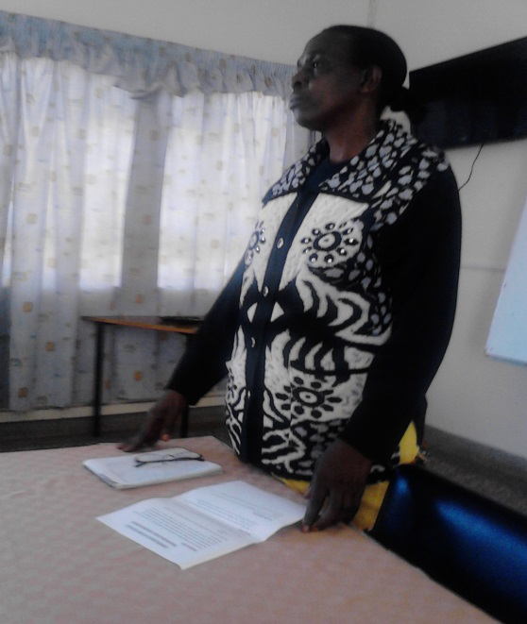 |  | Esther Were joined ICA in 1978 and left in 2005 due low funding of project activities. She attended the first HDTI in Kawangware. This first training might have been the International Training Institute or Human Development Training School and or the Human Development Training Institute because in the record shows the first two trainings talk place in Nairobi. Throughout Esther’s engagement, she worked in Kabiro HDP, Kamweleni HDP and the head office in Nairobi.  Esther has worked as a health worker in Kabiro where she was called back by the community to continue working with them after she left ICA. When she was assigned to Kamweleni she was in charge of the store for the HDTIs and children. In the head office she was in charge of filing, messenger and served as a tea girl.  Esther has continued to benefit in the ICA methods in terms of personal planning and AAMMEE (audience, attention motivate message, exercise evaluation) which was widely used in health care activities.  She generated activities by using the planning methods and now that she doesn’t have a job, the method reminded her that she can run a small business to help her survive after retirement.  As she worked in kabiro she discovered that the ICA methods are very effective because the project activities are still operational. When Esther abstained due to lack of funding from ICA she was not paid anything which pushed to find what to do and work much harder to survive. The income she gets is very low and cannot sustain her and the family. She has also realized that planning is not effective being alone.  The ICA methods are effective in organizing the community into small interest groups for initiating business although the income is very low initially, but they can improve gradually. The ICA methods are unique and very practical. ICA left the communities with lot life skills such as: how to make dish racks, water tanks, small garden etc. The methods are used even by retired people. They are still relevant because they have helped me to sustain my income generating activity (IGA). These methods can be used in the places where ICA did not replicate. The methods can still be applied in within operational and dormant projects.
Belice Kimanthi attended HDTI no. 12 at Kamweleni training centre. after the training she was assigned to Kyuluni Kivulusa (Mwala), Kamweleni (Machakos), Seremi (Kakamega) and Kawangware (Nairobi House).

Belice played severals roles including Field Facilitator, a circuitor, Finance Officer in several projects, Fundraising which included going for in-kind with Hubert and Action Planning. Also, holding conversations that lead to Consensus. Community mobilization, to form groups – Twone Mbee, Faida Poultry Farmers Women Group. Chairperson, Kee Ward, National Agricultural Inclusive Devt Project, Kee Ward Maendeleo ya Wanawake, Chairperson – mobilizing women to come to meetings.

The ToP methods she learned in the HDTI have enabled her to easily interact and cooperate with others. Currently I’m she is married and has three adult children. She lives together with her in laws and parents in-laws. She is self-sufficient with the ability plan and contributes to the family. she uses the Moto: Do our own Projects – dairy and poultry as income generation

Belice has used her training to fundraise for her local community by writing proposal to Heifer International who funded the group to buy dairy cows and chickens for the community, which benefited 25 members of the group. She Wrote another proposal to AMREF for Maanis Program with Twone Mbee, and bought 17 goats, 2 embroidery machines. These supported 1 elder person, 46 vulnerable children to secondary school and bought 126 school uniforms. Wrote a Proposal to LATIA in Kajiado which helped three groups with rabbits and solar lamps. She also helped to PLWHIV/AIDs to form two support groups. Have accessed help from government for own projects. Has trained as Paralegal with FIDA Kenya and she is helping women understand their rights** See case study below**

The ToP methods have helped Belice on accommodating differing views of people. For example, the cow project with Heifer where some members of the group felt there was more than given. The community expects handouts whilst I keep teaching them about doing it ourselves.

She has limited exposure to wide views – no mobility since I left ICA. One needs continuous learning for e.g. heifer training which I have a certificate. More awareness training in schools, churches and in public barazas. Has the ability to organize myself and others, my humility and understanding wide contexts of Kenyans and expatriates. Many of the groups she is part of don’t collapse but others start and die before one year. She has the ability to use skills learnt to benefit communities and her family e.g. proposal writing. She will be to be involved in future initiatives of networking and promoting ToP methods where we plan together and implement, let us revive ICA

Wellingiton Kitivi was recruited and attended the 2nd HDTI in Kamweleni. He was then assigned to Kuluku Human Development Project. Later assigned to Ulutya then to Kyuluni-Kivulusa as a project director. He has served as a circuitor in community mobilization, team leader, a facilitator in strategic planning, Workshops, Conversation and served on HDTI faculty. He also provided consultants services.

Wellington remembers very the Conversational methods, Community Mobilization, Workshop methods and Facilitation Training. He has continuously used these methods in Community approaches and designing materials for resolving disputes and conflicts. The way he mobilize the community to do something is different from others. He has managed to coordinated electricity installation in the community.

The community which went through ICA methods is affirmative or quick to response to barazas to discuss community issues. They prepared them to understand how to handle their own problems and Led them on how to plan their own development

The Institute of Cultural Affairs activities focused community development with emphasis on the human factors. Through this the communities where ICA worked have proved to be more active in development. They are active in Chief’s barazas and good at negotiating for services such as community electricity. They are work in collaboration with the National agricultural rural inclusive growth project ( NAR IGP). They have had Comprehensive community development plans. They have managed to control
Drug addicts’ vulnerable and marginalized groups, People living with disability, Yes you can see electricity in their town. Nutrition, poultry, mangoes, tomatoes, youth, common working/interests groups are formal forecast on specific projects

ICA methods are valuable, advantageous and applicable as far as community development is concerned. The ICA methods are extremely relevant. This is the right time to use ICA methods because of the setup of government system ( devolution units)

By being recruited as one of the facilitators or trainer. I wish the government could recognize ICA and invite them to train their officials e.g. social department in the counties

Peter Wambua |  | Peter Wambua graduated from the 2nd HDTI in Kamweleni. He was assigned to several Human Development Projects within Kenya which included Maikuu – Muthungue, Kituni (Bugoma), Matindiri (Nyandarua), Eldume (Marigat), Gatuto, Kilisa kya Mue, Muni – Mwanyani, and Mambrui Human Development Projects. In these projects he served in different capacities starting as a circuitor which was mainly community mobilization, a project director, a facilitator in planning workshops, consults and strategic planning using ICA methods.  The HDTI training in Kamweleni was basically theoretical. While in the field assignments was still training but practical such that Wambua was practicing what he learnt in class. Currently as chair of the community development group he has been accepted by the whole community where I settled recently. **As observed by Sammy a fellow community member** - Peter’s leadership skills are unique – soft spoken and unites the whole community. Peter is a farmer growing crops and livestock, he has sustained himself and self-sufficient because these methods have helped him to realize that he can do his own projects. He has used the knowledge to advance his family for example his children’s education is more advanced than his, where he has a doctor, a pharmacist and a nurse in his family. From Sammy: Peter has not involved himself in corruption – he has integrated his morals (from ICA) of dignity, he’s untouchable!  What Peter is doing is all about developing the wider community, for example he has lobbied for the Mukaa Sub County DC headquarters, the police station and school fees bursaries for needy children. He has Organized fundraising for community projects, churches and primary school. From Sammy who spoke highly of the ICA approaches: Peter has facilitated discussions in Kwa Ndeke community which led to achieve people ‘oriented visions’ i.e. he sought the land for the DC residency and has realized that dream  Peter has encountered challenges while using ICA methods some of which were self-inflicting such as limiting his thinking that we do not have money which restricted the opportunities and social capital in our community. Realization that not all are pro-development e.g. the Kwa Ndeke primary school, establishing the Salvation Army and Catholic Churches. He has faced opposition but used his leadership skills to access permission. Isolated within the community but those he wants to work with are not available. Peter is proud and satisfied that services are reaching the majority of the community that is the school, hospital even the DC office. He was critical in advocating for their formation. Community Mobilization is essential and it needs leadership. (From Sammy): Peter has the ability to influence others to participate in community activities.  Peter has learned many other skills but still ICA methods are Very relevant as today’s public participation is not real participation since it is tailored participation thus telling people what they want to hear. ICA methods was beyond todays thinking. It was ‘bottom-up and not sugar coating like the public participation we see today. Therefore the idea of reactivating and harmonizing ICA methods could be a welcome idea whose time has come.  We will need refresher training in order to organize, introduce and advance these to people like Sammy who are critical in community development “teach us about real public participation” Where is ICA? Can we have an ICAK CHAPTER, led by Kenyans to give back to your communities?  In terms of the way forward –- What was the orientation of this questionnaire - where are you going with this exercise? Or after compiling it, what do you see happening in future? ICA is not a commercial entity, why all these?
Mark Lusweti  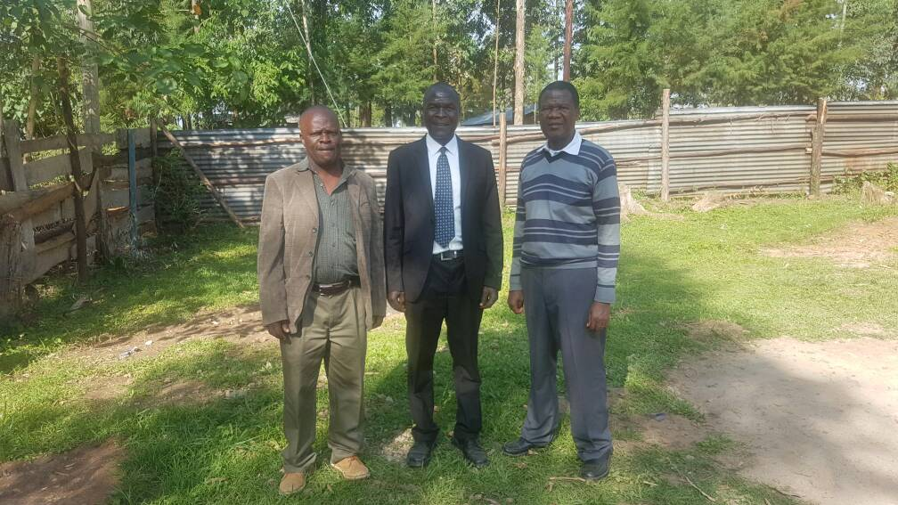 |  | Mark Lusweti graduated from 5th HDTI in Kamweleni. After the training, he was assigned to Vwevwesi, Kamweleni, Kalwani-Shamalogo and Hawinga Human Development Projects respectively. In these projects Mark was in charge of the health activities which also included going to schools. He was a core staff in Nairobi Health, a major programme in slum areas of Nairobi city.  The training in Kamweleni and the field practical experience molded Mark to become a Trainer, a Facilitator, a finance manager and a programme manager. He is conversant with Strategic planning processes, facilitation methods, training of trainers, Finance and Resource management. He also uses methods to plan for himself with the little resources he have and keep records for reflection and references.  The ICA methods could be very effective especially consult methods at this point time since the public services have been devolved into small community units to plan and manage their resources.  ICA grassroots approach makes the community own their projects. While in Isinya, my Quarterly reports sent to opinion leaders, administrations exposed ICA work and created good relations. ICA planning methodology will put the community on the track or be focused all the time on every devolved project and all stake holders who are the communities where planning starts. Such stakeholders are development committees, village and ward administrators, members of County Assembly (MCA) and other devolved functions.  The ICA methodology could become a true way of approach in the present times. To do this effectively needs a network of ICA alumina committed and determined to do excellent work. This could include refining the methods with consideration of the current situation and be ready to train others.
Beatrice Imali  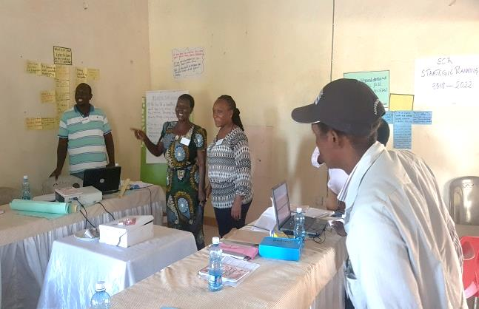 |  | Beatrice Imali graduated the 12th HDTI in Kamweleni and was assigned to Shalemba in Voi. Six months later she was assigned to Vwevwesi Human Development Project. Subsequently assigned to Kalwani Shamalogo, Khwisero and Kamweleni Human Development Projects. Each assignment lasting 6 months, 1, 12, 3, 3 and 2 years respectively  From the experience, Beatrice is a qualified facilitator in Strategic planning, Leading meetings, Workshop and Conservational methods and community mobilization within irrigation project area in Ahero. She has coordinated food security and nutrition programme, Positive management programme (HIV). She facilitated the Cooperative Members Participation Programme (CMPP)  Beatrice has continued to use ICA ToP Methods (workshop, ORID, Conversation and Strategic Planning Processes) while facilitating workshops, group meetings, training and community mobilization. She is able to cop up with any situation and can apply this methods anywhere for example in church and in family meetings  The community which went through ICA methods has the confidence as they apply the approaches, or when they implement their activities. They are the entry point for other organization they have become key contact people.  However the challenges have been for the communities to understand the methods and competency to continue using and also apply in the work of other organizations. There is still need to train the community further for them understand the ICA concept especially during the planning level.  Beatrice has been motivated to do the work without getting tired because you can apply these methods anywhere because of the flexibility that they have. People always want to associate with ICA people because of well-coordinated processes. The community has changed in their way of thinking and also the way they implement their activities.  The ICA methods are simple, real and practical. They build an individual in character and self-confidence. They are down top approach that promotes participation. The methods are involving and participatory in nature. So many methods being used, but the ICA methods are still relevant especially when they are used in down top approaches. They are relevant because they made us to be who we are and I’m willing to be involved in planning and sensitization of communities on ToP methods. These will mean developing a curriculum that will harmonize all ICA methods. Train young people about ICA methods so that they may take over from us. We need to adapt the current way of facilitating e.g use of power point and sticky wall etc.
Pamela Nyauma  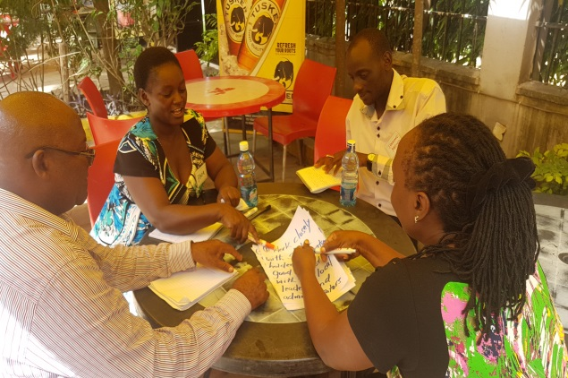 |  | Pamela Nyauma joined ICA in 1999 as a nutritionist and was stationed at Mariakani ICA office. She never attended the HDTI training but rather she learnt ICA methods from the ICA staff.  Among the methods she learnt were facilitation, workshop and group discussion methods. Since then she has Conduct facilitation, Workshops for groups, Group discussions during training a workshop, exchange forum, strategic planning and assessment sessions.  The community understands their situation better when ICA methods are used and it makes it easier to realize set objectives for example in strategic planning. The community owns the outcome because of the participatory approach. Both the facilitators and the participants enjoy the process because of its participatory nature which leaves a strong bond between the community and the facilitator. There has been no major challenges when using ICA methods because every group has to be addressed using a relevant top method.  Pamela is encouraged to carryout community development work since it is result oriented and because of the change it brings in peoples life. When you see health children and mothers due to nutrition training and vaccination. When see food security in the community due to agricultural training, and then you are fulfilled.  The ICA methods are very powerful because they lead you to achieving your set goals and objectives. The methods are very relevant because they are widely used in organizations churches, social groups etc.  In community development projects, county, national government planning, and other NGOs parastatals churches, schools in various committees and boards could benefit from these methods.  As a facilitator I recommend ICA top methods should be broadcasted all over the region because of its relevance eg a book can be published, video records
Jackson Simiyu |  | Jackson Simiyu graduated from the 5th HDTI in Kamweleni. After the training he was assigned in several projects including Kamweleni, Kalwani-Shamalogo, Ainabukoi and then back to Seremi Cluster (Kalwani-Shamalogo).  He was first assigned as a circuitor then later became a Project director/ manager, Trainer of trainers on community organization, Training leaders/ communities/group on leadership skills/project planning/ monitoring. He went further and became a Section gun/ training communities of identification, Community organization methods, Project planning, monitoring and evaluation. Jackson trained targeted groups/ leaders/ communities on leadership skills, Project consultation and Lens/doop/ndio/ methods of empowering leaders’ communities.  Jackson still use participatory methods in meetings and self-help groups especially facilitating Project planning/ monitoring/ evaluation of activities planned. Empowering communities and groups on identifying their issues, needs, ideas for planning and implementation. As an individual he uses ICA methods and reflects on it after a month and quarterly to make sure activities happens as planned. He keeps records for plans and accomplishments.  Communities trained through ICA methods uses participatory methodology to generate ideas and plan for their development activities and also deal with their own issues. However, limited time when implementing the planned activities and Illiteracy in some community leaders are some of challenges.  Sometimes government policies have been hindering grassroots development.  There’s need to train MCA’s, Village administrators, locational leaders, Ward administration committees, Sub county development committees in ICA participatory methods  Jackson is available to participate in any effort to review ICA methods and make plans to train more groups, society, leaders, and organizations that could be interested. It needs self-commitment and determinations that will make ICA methods relevant in this region currently and in the future.
Nelson Sayia |  | Nelson Sayia graduated from 7th HDTI in Kamweleni. He was then assigned to Kaongo in Meru then later to Kamweleni in Machakos, Mugumoini in Murang’a, Vwevwesi in Kilifi, Kyuluni-Kivulusa in Machakos and Nambacha Kakamega respectively.  Nelson rose from being a circuitor to a Locational and divisional programme coordinator, a section trainer, project director and section programme coordinator. He facilitated project planning, monitoring and evaluation. He participated in village consults facilitation, Community organization and Community leadership training.  As a BOM chairman, Nelson is able to apply participatory methods to allow each member to contribute toward the school developments plans and in solving issues. In identifying community issues and in working as an individual and as a team. He is able to participate in any community development activities. He is also able to keep records and write project reports.  The ICA methods helped the community to identify their development needs, planning and implementing their activities successfully. Illiteracy proved to be a challenge some communities. Limited time in implementing the planned activities. Changing the negative attitude of ownership of community’s activities.  There is greater awareness in communities that plan and work together using participatory approaches to achieve their development goals. This applied in the community development planning and implementation makes communities own their projects. The government is trying very hard to apply participation for inclusion but is not good enough to make it meaningful. People are empowered in decision making when they participate in ideas of their own development needs.  In wards where the Ward administrations sensitize the community in identifying projects for development needs it will be good to get more people participation. Community administrators using the approach to implement the planned activities in communities it make it more effective.  I’m available at any time to participate in any network, society or organization using the relevant ICA methods.
Joseph Karandini |  | Joseph Karandini graduated from 8th HDTI in Kamweleni. He was assigned in Thanke Human Development Project, then later to Hawinga and Kalwani-Shamalogo HDP. He became a qualified facilitator in DOOP methods which he used in facilitating village and locational cluster planning events.  Joseph has continued to use DOOP methods even during his weekly Barazas as a Chief. He is able to keep records and also interact with all groups and people in his location. In places where ICA worked or where a former ICA staff is still active the communities are well informed and participation in public activities is high. They are more skilled in allowing participatory contribution during meetings.  This evidence gathering is important and more so if the findings could be documented to enable those who will to pursue ICA ToP methods. These methods are needed in this devolved system of government more than before. ICA method of three year planning, then broken down to quarter and one month plan was very effective.  The ICA methods were very good in building teamwork, during planning at grassroots in determining projects needed. Setting up Sub-location and location development committees and training the leaders in their leadership responsibilities. Coordinating weekly and monthly meetings organizing quarterly community assemblies was very powerful in the approaches of empowering public participation. Devolution has come to the county level and ICA methods of planning could be very much relevant for effective planning.

